AUGUSTANA LUTHERAN CHURCH
17th Sunday after Pentecost– 10 am

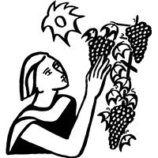

September 20, 2026
*Denotes when we stand

*Gathering
P: Generous God,
you call us into your vineyard in every season of our lives. As the seasons turn, teach us the sacred work of letting go. Help us release what we cannot control, the comparisons we make, and the scores we keep. Remind us that your kingdom is not built upon what we earn, but upon your abundant grace. Give us gratitude for what has been, courage to release what has ended, and trust for what is yet to come. Gather us now in your grace and lead us into the new thing you are creating.
P: In the name of the Father, and of the ☩ Son, and of the Holy Spirit.
Amen.

*Confession and Forgiveness
P: Almighty God, to whom all hearts are open, all desires known, and from whom no secrets are hid: cleanse the thoughts of our hearts by the inspiration of your Holy Spirit, that we may perfectly love you and worthily magnify your holy name, through Jesus Christ our Lord.
Amen.

P: Let us confess our sin in the presence of God and of one another.
Silence is kept for reflection.

P: Gracious God,
C: have mercy on us. We confess that we have turned from you and given ourselves into the power of sin. We are truly sorry and humbly repent. In your compassion forgive us our sins, known and unknown, things we have done and things we have failed to do. Turn us again to you, and uphold us by your Spirit, so that we may live and serve you in newness of life through Jesus Christ, our Savior and Lord.
Amen.

P: God, who is rich in mercy, loved us even when we were dead in sin, and made us alive together with Christ. By grace you have been saved. In the name of ☩ Jesus Christ, your sins are forgiven. Almighty God strengthen you with power through the Holy Spirit, that Christ may live in your hearts through faith.
Amen.

*Thanksgiving for Baptism

P: Joined to Christ in the waters of baptism,
we are clothed with God's mercy and forgiveness.
Let us give thanks for the gift of baptism.

We give you thanks, O God,
for in the beginning your Spirit moved over the waters
and by your Word you created the world,
calling forth life in which you took delight.

Through the waters of the flood you delivered Noah and his family.
Through the sea you led your people Israel from slavery into freedom.
At the river your Son was baptized by John and anointed with the Holy Spirit.
By water and your Word you claim us as daughters and sons,
making us heirs of your promise and servants of all.

We praise you for the gift of water that sustains life,
and above all we praise you for the gift of new life in Jesus Christ.
Shower us with your Spirit,
and renew our lives with your forgiveness, grace, and love.

Amen.

*Opening Music – “Lord of All Hopefulness” – ELW 765
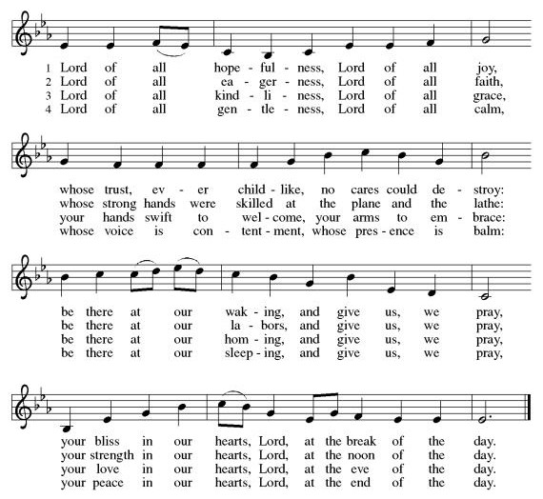

*Greeting
P: The grace of our Lord Jesus Christ, the love of God, and the communion of the Holy Spirit be with you all.
C: And also with you.

*Kyrie
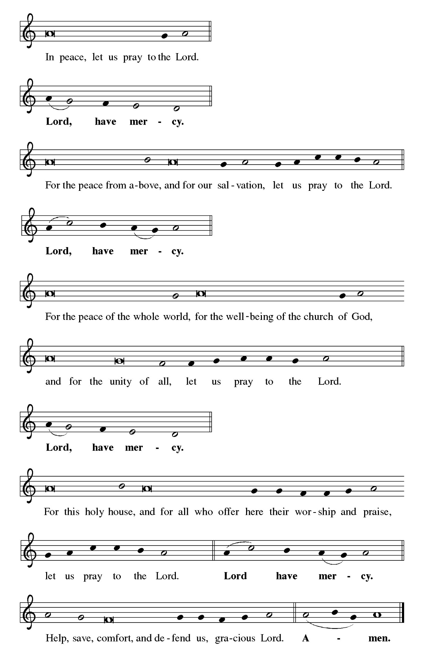
*Hymn of Praise – “This is the Feast” – page 149
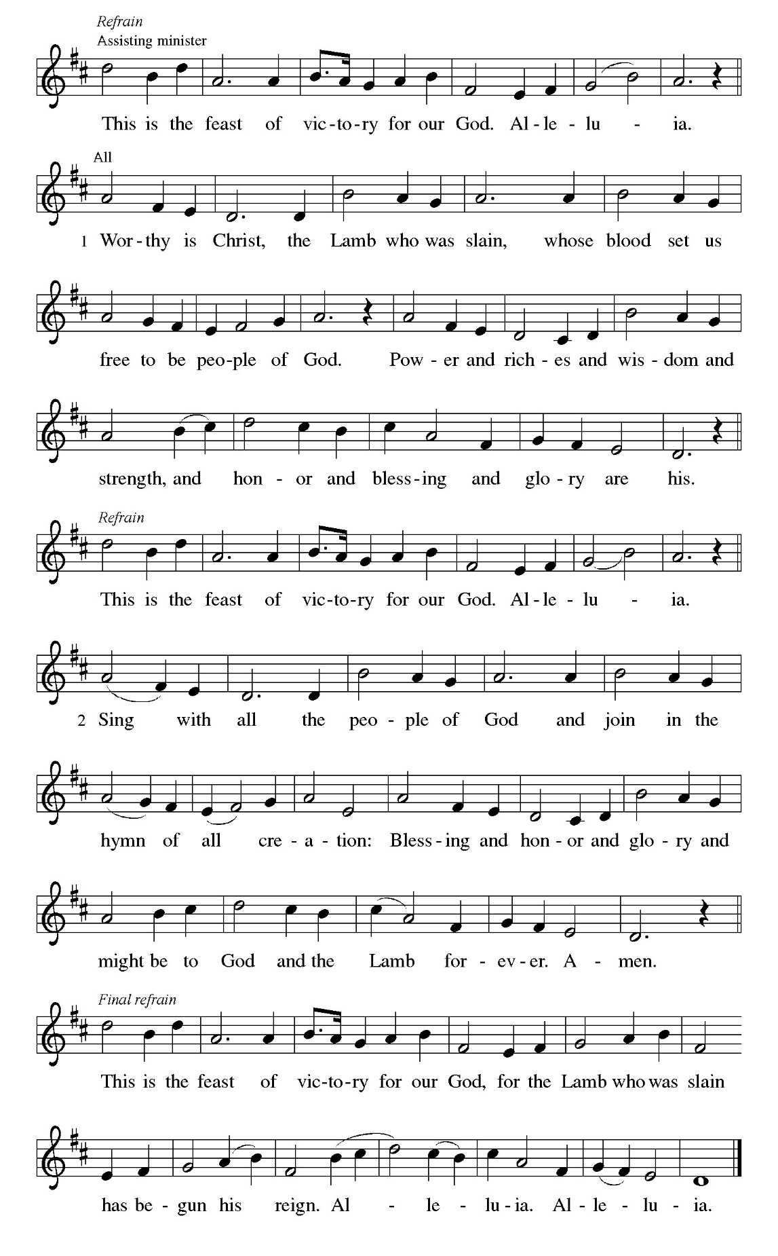

*Prayer of the Day
P: Almighty and eternal God, you show perpetual lovingkindness to us your servants. Because we cannot rely on our own abilities, grant us your merciful judgment, and train us to embody the generosity of your Son, Jesus Christ, our Savior and Lord.
C: Amen.

First Lesson – Jonah 3:10—4:11

A: A reading from the book of Jonah the 3rd and 4th chapters

¹⁰ When God saw what [the people of Ninevah] did, how they turned from their evil ways, God changed his mind about the calamity that he had said he would bring upon them, and he did not do it.
^{4:1} But this was very displeasing to Jonah, and he became angry. ² He prayed to the Lord and said, “O Lord! Is not this what I said while I was still in my own country? That is why I fled to Tarshish at the beginning, for I knew that you are a gracious and merciful God, slow to anger, abounding in steadfast love, and relenting from punishment. ³ And now, O Lord, please take my life from me, for it is better for me to die than to live.” ⁴ And the Lord said, “Is it right for you to be angry?” ⁵ Then Jonah went out of the city and sat down east of the city and made a booth for himself there. He sat under it in the shade, waiting to see what would become of the city.
⁶ The Lord God appointed a bush and made it come up over Jonah, to give shade over his head, to save him from his discomfort, so Jonah was very happy about the bush. ⁷ But when dawn came up the next day, God appointed a worm that attacked the bush, so that it withered. ⁸ When the sun rose, God prepared a sultry east wind, and the sun beat down on the head of Jonah so that he was faint and asked that he might die. He said, “It is better for me to die than to live.”
⁹ But God said to Jonah, “Is it right for you to be angry about the bush?” And he said, “Yes, angry enough to die.” ¹⁰ Then the Lord said, “You are concerned about the bush, for which you did not labor and which you did not grow; it came into being in a night and perished in a night. ¹¹ And should I not be concerned about Nineveh, that great city, in which there are more than a hundred and twenty thousand persons who do not know their right hand from their left and also many animals?”

A: Word of God, Word of Life.
C: Thanks be to God.

Appointed Psalm – Psalm 145:1-8
A: Let us read Psalm 145 responsively.

¹ I will exalt you, my God and king,
and bless your name forever and ever.
² Every day will I bless you
and praise your name forever and ever.
³ Great is the Lord and greatly to be praised!
There is no end to your greatness.
⁴ One generation shall praise your works to another
and shall declare your power.
⁵ I will speak of the glorious splendor of your majesty
and all your marvelous works.
⁶ They shall tell of the might of your wondrous acts,
and I will recount your greatness.
⁷ They shall publish the remembrance of your great goodness;
they shall sing joyfully of your righteousness.
⁸ The Lord is gracious and full of compassion,
slow to anger and abounding in steadfast love.

Second Lesson – Philippians 1:21-30

A: A reading from St. Paul's letter to the church in Philippi the 1st chapter,

²¹ For to me, living is Christ and dying is gain. ²² If I am to live in the flesh, that means fruitful labor for me, yet I cannot say which I will choose. ²³ I am hard pressed between the two: my desire is to depart and be with Christ, for that is far better, ²⁴ but to remain in the flesh is more necessary for you. ²⁵ Since I am convinced of this, I know that I will remain and continue with all of you for your progress and joy in faith, ²⁶ so that, by my presence again with you, your boast might abound in Christ Jesus because of me.
²⁷ Only, live your life in a manner worthy of the gospel of Christ, so that, whether I come and see you or am absent and hear about you, I will know that you are standing firm in one spirit, striving side by side with one mind for the faith of the gospel ²⁸ and in no way frightened by those opposing you. For them, this is evidence of their destruction but of your salvation. And this is God’s doing. ²⁹ For he has graciously granted you the privilege not only of believing in Christ but of suffering for him as well, ³⁰ since you are having the same struggle that you saw I had and now hear that I still have.

A: Word of God, Word of Life. C: Thanks be to God.

*Gospel Acclamation
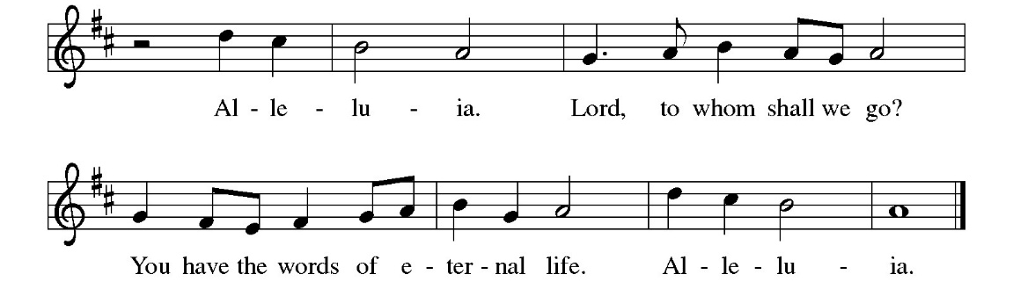

*Gospel – Matthew 20:1-16
P: The holy gospel according to St. Matthew the 20th chapter.
C: Glory to you, O Lord.

[Jesus said to the disciples:] ¹ “The kingdom of heaven is like a landowner who went out early in the morning to hire laborers for his vineyard. ² After agreeing with the laborers for a denarius for the day, he sent them into his vineyard. ³ When he went out about nine o’clock, he saw others standing idle in the marketplace, ⁴ and he said to them, ‘You also go into the vineyard, and I will pay you whatever is right.’ So they went. ⁵ When he went out again about noon and about three o’clock, he did the same. ⁶ And about five o’clock he went out and found others standing around, and he said to them, ‘Why are you standing here idle all day?’ ⁷ They said to him, ‘Because no one has hired us.’ He said to them, ‘You also go into the vineyard.’ ⁸ When evening came, the owner of the vineyard said to his manager, ‘Call the laborers and give them their pay, beginning with the last and then going to the first.’ ⁹ When those hired about five o’clock came, each of them received a denarius. ¹⁰ Now when the first came, they thought they would receive more; but each of them also received a denarius. ¹¹ And when they received it, they grumbled against the landowner, ¹² saying, ‘These last worked only one hour, and you have made them equal to us who have borne the burden of the day and the scorching heat.’ ¹³ But he replied to one of them, ‘Friend, I am doing you no wrong; did you not agree with me for a denarius? ¹⁴ Take what belongs to you and go; I choose to give to this last the same as I give to you. ¹⁵ Am I not allowed to do what I choose with what belongs to me? Or are you envious because I am generous?’ ¹⁶ So the last will be first, and the first will be last.”

P: This is the Gospel of the Lord!
C: Praise to you, O Christ.

Children’s Sermon/Sermon

Hymn of the Day – “For by Grace You Have Been Saved” – ELW 598
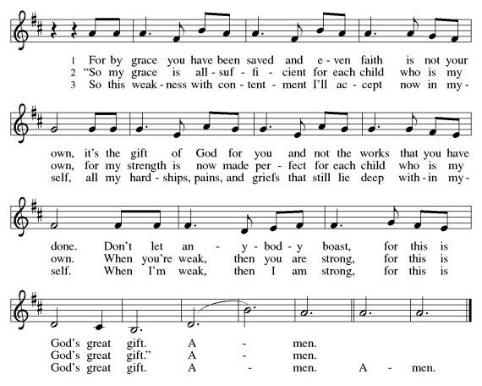

Apostle’s Creed
A: Let us proclaim our faith with the words of the Apostle’s Creed.
C: I believe in God, the Father almighty, creator of heaven and earth. I believe in Jesus Christ, God’s only Son, our Lord, who was conceived by the Holy Spirit, born of the virgin Mary, suffered under Pontius Pilate, was crucified, died, and was buried; he descended to the dead. On the third day he rose again; he ascended into heaven, he is seated at the right hand of the Father, and he will come to judge the living and the dead.
I believe in the Holy Spirit, the holy catholic church, the communion of saints, the forgiveness of sins, the resurrection of the body, and the life everlasting. Amen.

Prayers of Intercession

Reminded of God’s gracious and abundant love, we offer our prayers, confident that God hears us.
A brief silence.

Hold your church accountable for our unwillingness to share your good news and our anger at your generosity to others. Nourish us by your grace to be witnesses to your love. Hear us, O God.
Your mercy is great.

God of peace, confound the plans of those who wage war, profit from violence, and sow hatred and fear. Protect all who suffer in places torn by conflict, and strengthen those who work for peace, justice, and reconciliation—in the nations of the world and within our own communities and homes. Make us instruments of your peace. Hear us, O God.
Your mercy is great.

Show employers the benefits of equal pay standards for all their employees. Reconcile conflicts between employees. Fill places of employment with camaraderie, and bring an end to employment disparity. Hear us, O God.
Your mercy is great.

Encourage any who cannot work or who cannot work a full day with the truth that their value comes from your everlasting love for them. Provide for those who are injured, ill, and for all in any need (especially). Hear us, O God.
Your mercy is great.

Strengthen all those in this congregation whose labor serves the needs of others in the community. Inspire all in this congregation to support community endeavors with our time and talents. Hear us, O God.
Your mercy is great.

Comfort us with the promise of the resurrection as we remember all our loved ones whose desire to be with Jesus is fulfilled. Hear us, O God.
Your mercy is great.

Grant the prayers we have offered, what we have forgotten to ask, and whatever else you see that we need. We ask this in Jesus’ name.
Amen.

*Passing of Peace
A: From the gospel of Matthew. ²³So when you are offering your gift at the altar, if you remember that your brother or sister has something against you, ²⁴leave your gift there before the altar and go; first be reconciled to your brother or sister and then come and offer your gift.
A: The peace of the Lord be with you always.
C: And also with you.
A: Let us now offer peace to one another as you feel comfortable

Announcements

Offering
A: Let us now return to God, that which God has first given us; our tithes and our offerings.

Musical Offering

*Offertory Canticle – “Let the Vineyards” – ELW 184

*Offertory Prayer
A: Lord of the harvest, we return to you a portion of what you have given to us. Turn us to set our hope not on the uncertainty of riches, but on you, who richly provides for us. Multiply what we have gathered to bless all who are suffering and in need, through Jesus Christ our Lord.
C: Amen.

*Great Thanksgiving
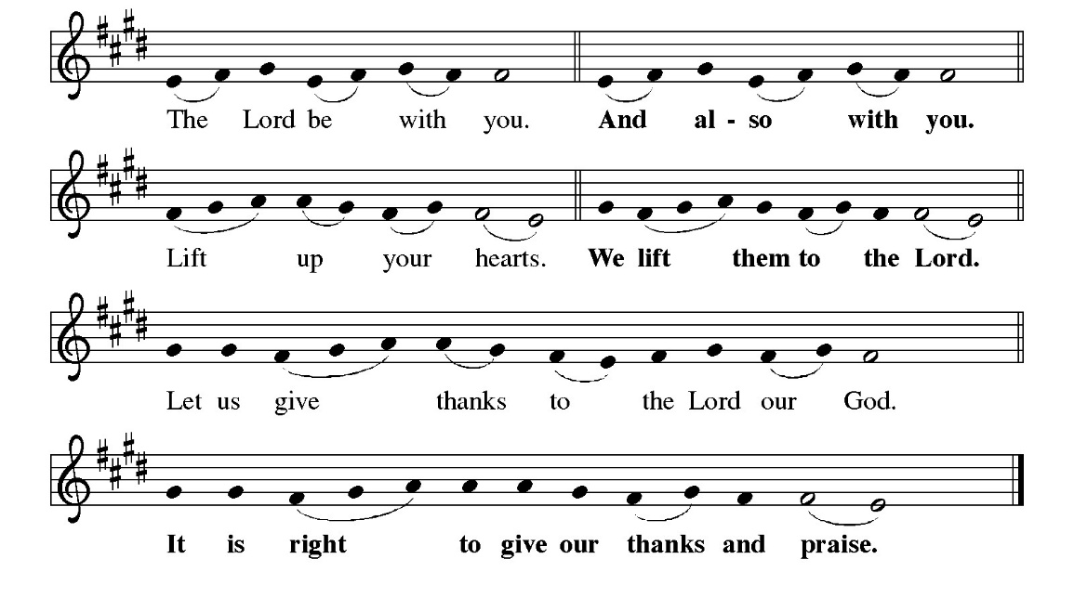
*Proper Preface
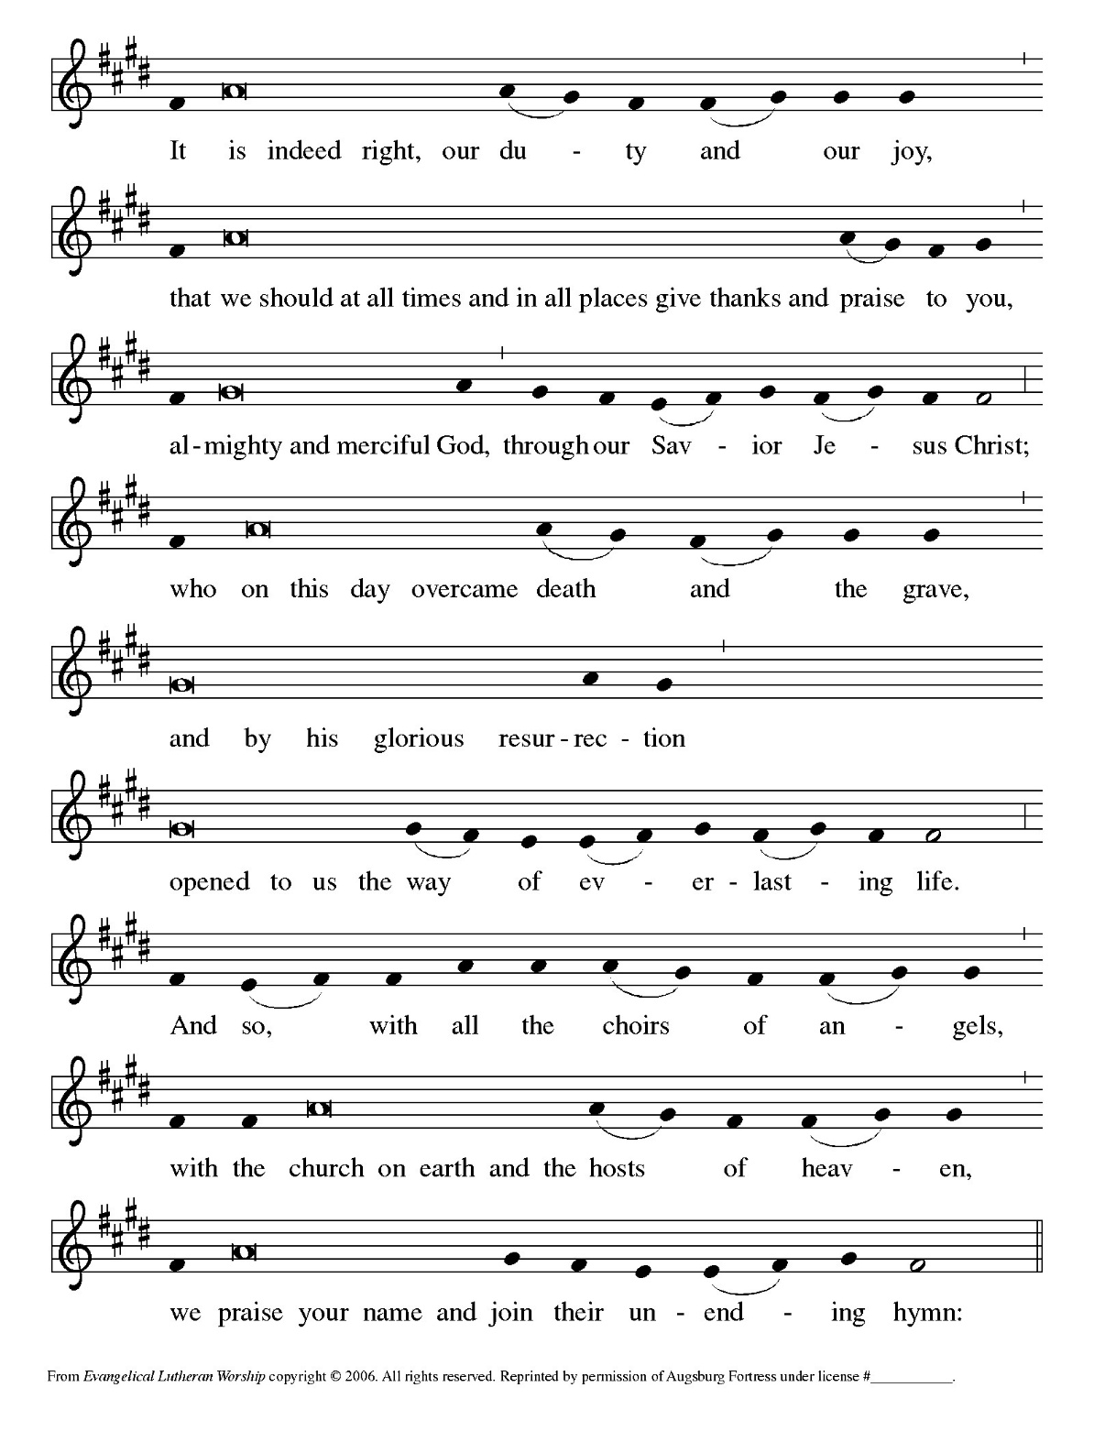
*Sanctus
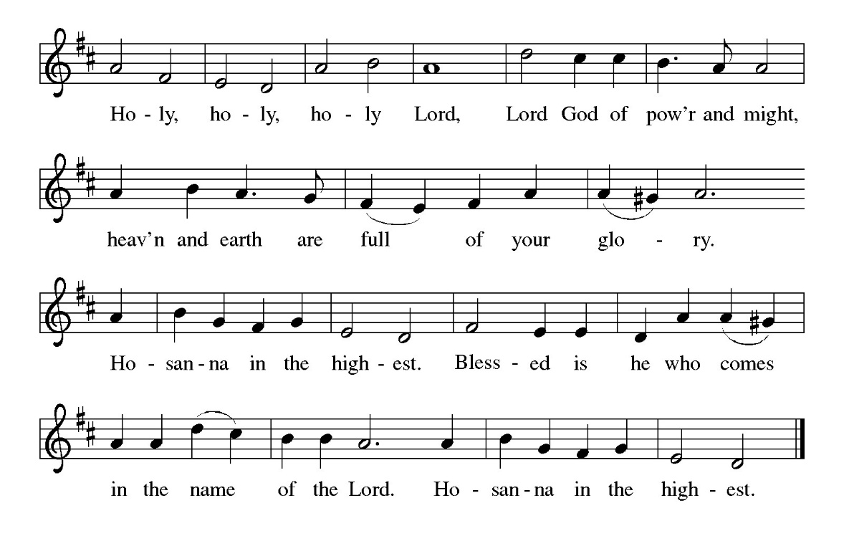

*Eucharistic Prayer
P: You are indeed holy, almighty and merciful God. You are most holy, and great is the majesty of your glory. You so loved the world that you gave your only Son, so that everyone who believes in him may not perish but have eternal life. We give you thanks for his coming into the world to fulfill for us your holy will and to accomplish all things for our salvation.

*Words of Institution
P: On the night of his betrayal, our Lord Jesus took bread and gave thanks; broke it and gave it to his disciples saying: “Take and eat; this is my body given for you. Do this for the remembrance of me.”
After supper, he took the cup, gave thanks, and gave it for all to drink saying: “This cup is the new covenant in my blood, shed for you and for all people for the forgiveness of sin. Do this for the remembrance of me.”

*Mystery of Faith
P: Remembering, therefore, Jesus’ life, death, resurrection, and ascension, we await his coming in glory as we proclaim the mystery of faith.
C: Christ has died, Christ is risen, Christ will come again.

*Epiclesis
P: Pour out upon us the Spirit of your love, O Lord, and unite the wills of all who share this heavenly food, the body and blood of Jesus Christ, our Lord; to whom, with you and the Holy Spirit, be all honor and glory, now and forever.
C: Amen

*Lord’s Prayer
P: Let us pray as our Lord has taught us
C: Our Father, who art in heaven, hallowed be thy name, thy kingdom come, thy will be done, on earth as it is in heaven. Give us this day our daily bread; and forgive us our trespasses, as we forgive those who trespass against us; and lead us not into temptation but deliver us from evil. For thine is the kingdom, and the power, and the glory, forever and ever. Amen.

P: Through Him, with Him, and in Him, in the unity of the Holy Spirit, all glory and honor is yours, almighty Father, for ever and ever. Amen

*Invitation to Communion
P: Jesus welcomes sinners and eats with them. Come to this meal of mercy for all are welcome

Agnus Dei
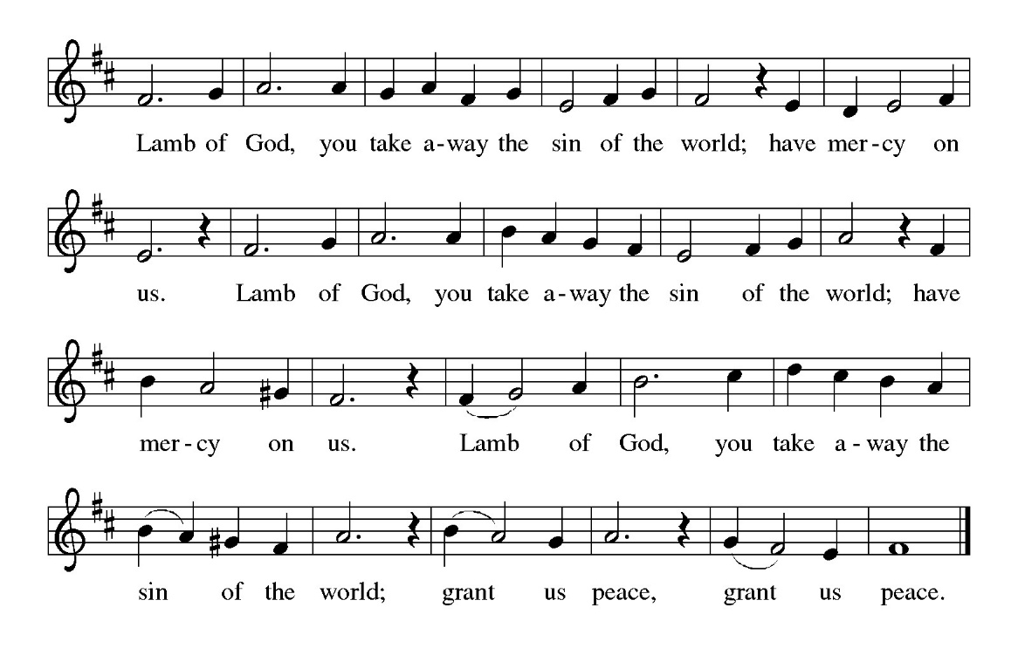

Communion Hymns –
ELW 614 — There Is a Balm in Gilead
ELW 661 — I Love to Tell the Story
ELW 708 — Jesu, Jesu, Fill Us with Your Love

*Post Communion Blessing
P: The body and blood of our Lord Jesus Christ strengthen you, and forever ☩ keep you in his grace.
C: Amen.

*Post Communion Canticle “Thankful Hearts and Voices Raise” ELW 207

*Post Communion Prayer
A: O God, our life, our strength, our food, we give you thanks for sustaining us with the body and blood of your Son. By your Holy Spirit, enliven us to be his body in the world, that more and more we will give you praise and serve your earth and its many peoples, through Jesus Christ, our Savior and Lord.

C: Amen.

*Blessing
P: May The Lord bless you and keep you.
May the Lord’s face shine on you with grace and mercy.
May the Lord look upon you all with favor and ☩ give you peace.
C: Amen.

*Sending Hymn – “How Sweet the Name of Jesus Sounds” – ELW 620
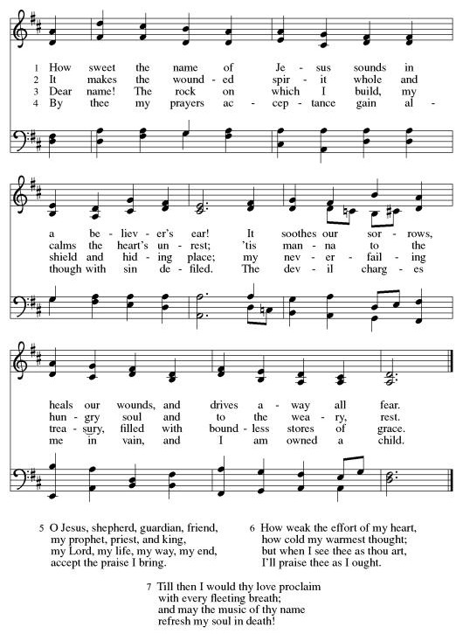
P.: We are not perfect—
C: We are being healed.
P: We are not alone—
C: We belong to Christ and to one another.
P: We are not finished—
C: God is still at work in us.

P: Let us praise Him together and sing as we depart!

*DOXOLOGY
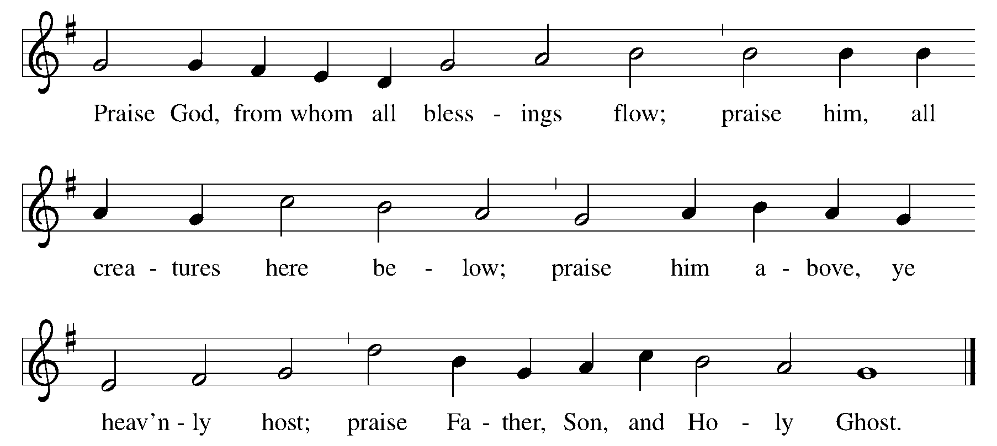

Amen

*Dismissal
A: Go in peace. Remember the poor.

C: Thanks be to God. Alleluia!

Postlude


Look for news, information, and videos on all our social media platforms.
Music and texts from Evangelical Lutheran Worship © 2006 Augsburg Fortress; All Creation Sings © 2020 & SundaysandSeasons.com © Augsburg Fortress 2018. All rights reserved. Reprinted by permission under Augsburg Fortress Liturgies Annual License SB129632 and One License A-722029. Biblical texts from New Revised Standard Version Bible, © 1989, Division of Christian Education of the National Council of the Churches of Christ in the United States of America. Used by permission.

