AUGUSTANA LUTHERAN CHURCH
7th Sunday of Easter – 10 am
May 17, 2026
*Denotes when we stand

Prelude

*Thanksgiving for Baptism
P: In the name of the ☩ Father, and of the Son and of the Holy Spirit.
C: Amen.
P: Alleluia! Christ is risen.
C: Christ is risen indeed. Alleluia!

P: Refreshed by the resurrection life we share in Christ, let us give thanks for the gift of baptism.

P: We thank you, risen Christ, for these waters where you make us new, leading us from death to life, from tears to joy. We bless you, risen Christ, that your Spirit comes to us in the grace-filled waters of rebirth, like rains to our thirsting earth, like streams that revive our souls, like cups of cool water shared with strangers. Breathe your peace on your church when we hide in fear. Clothe us with your mercy and forgiveness. Send us companions on our journey as we share your life. Make us one, risen Christ. Cleanse our hearts. Shower us with life. To you be given all praise, with the Holy Spirit, in the glory of God, now and forever.
C: Amen.

*Entrance Hymn – “All Are Welcome” – ELW 641

*Greeting
P: The grace of our Lord Jesus Christ, the love of God, and the communion of the Holy Spirit be with you all.
C: And also with you.

*Kyrie (The assembly sings all parts)
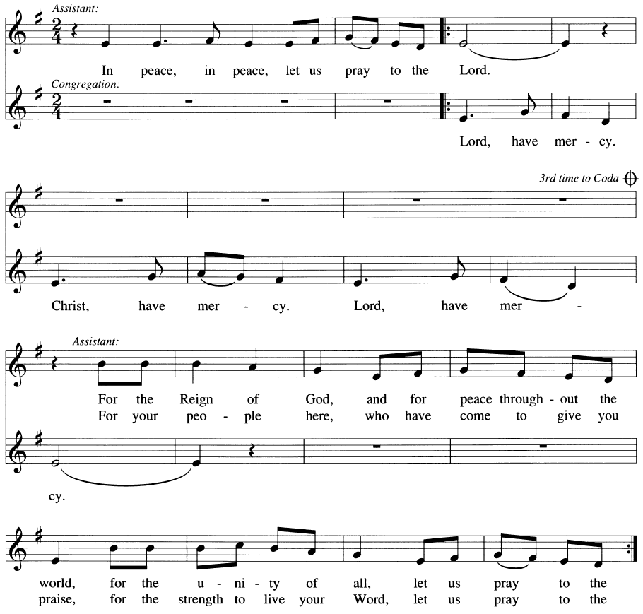
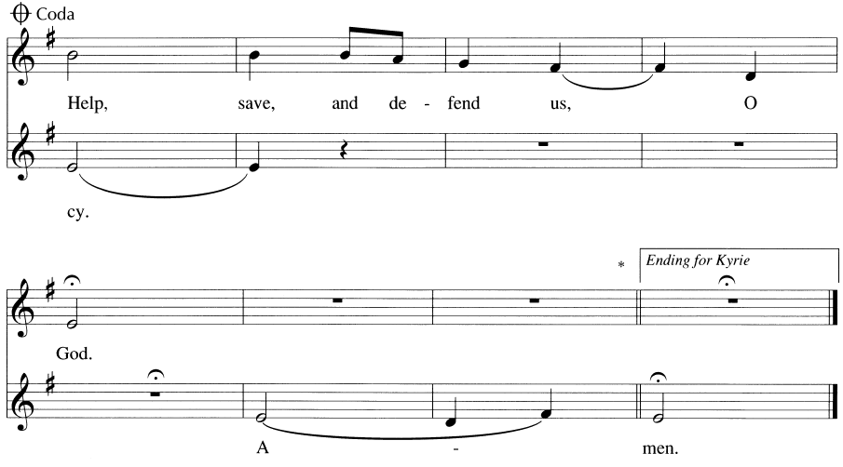

*Hymn of Praise – Now the Feast
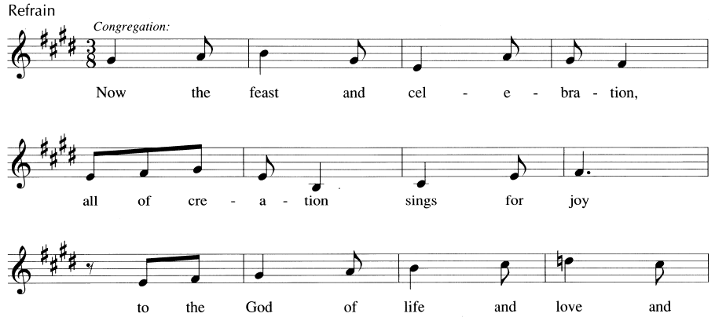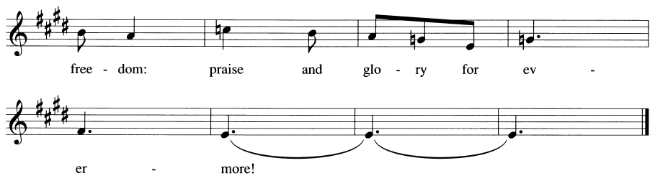
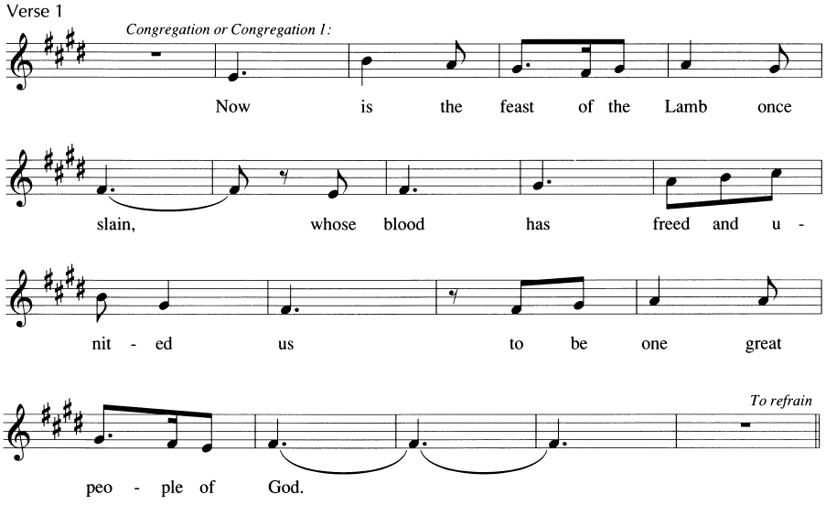
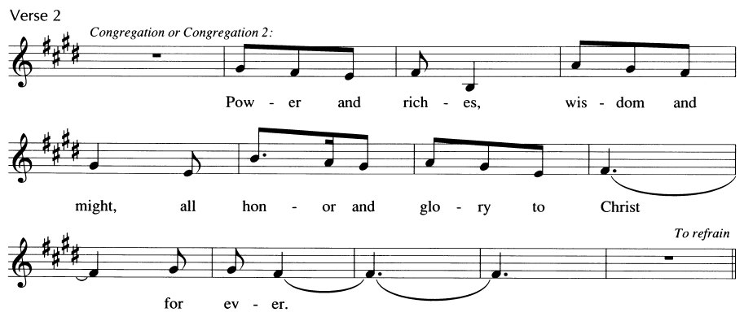
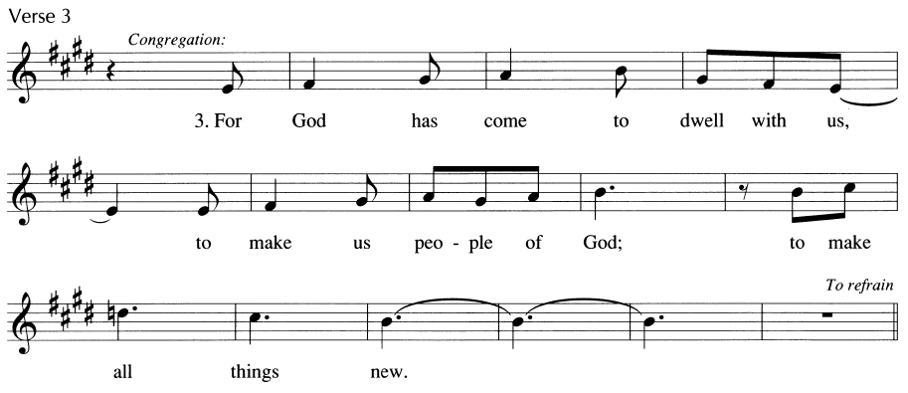

*Salutation
P: The Lord be with You!
C: And also with you!

*Prayer of the Day
P: Almighty and ever-living God, you hold together all things in heaven and on earth. In your great mercy receive the prayers of all your children and give to all the world the Spirit of your truth and peace, through Jesus Christ, our Savior and Lord, who lives and reigns with you and the Holy Spirit, one God, now and forever. C: Amen.

First Lesson – Acts 1:6-14

A: A reading from the book of Acts the 1st chapter
⁶ When the apostles had come together, they asked Jesus, “Lord, is this the time when you will restore the kingdom to Israel?” ⁷ Jesus replied, “It is not for you to know the times or periods that the Father has set by his own authority. ⁸ But you will receive power when the Holy Spirit has come upon you, and you will be my witnesses in Jerusalem, in all Judea and Samaria, and to the ends of the earth.” ⁹ When he had said this, as they were watching, he was lifted up, and a cloud took him out of their sight. ¹⁰ While he was going and they were gazing up toward heaven, suddenly two men in white robes stood by them. ¹¹ They said, “Men of Galilee, why do you stand looking up toward heaven? This Jesus, who has been taken up from you into heaven, will come in the same way as you saw him go into heaven.”
¹² Then they returned to Jerusalem from the mount called Olivet, which is near Jerusalem, a Sabbath day’s journey away. ¹³ When they had entered the city, they went to the room upstairs where they were staying: Peter, and John, and James, and Andrew, Philip and Thomas, Bartholomew and Matthew, James son of Alphaeus, and Simon the Zealot, and Judas son of James. ¹⁴ All these were constantly devoting themselves to prayer, together with certain women, including Mary the mother of Jesus, as well as his brothers.

A: Word of God, Word of Life. C: Thanks be to God.
Appointed Psalm – Ecclesiastes 3:1-8
A: Let us read Ecclesiastes chapter 3 responsively.
¹For everything there is a season, and a time for every matter under heaven:
²a time to be born, and a time to die;
a time to plant, and a time to pluck up what is planted;
³a time to kill, and a time to heal;
a time to break down, and a time to build up;
⁴a time to weep, and a time to laugh;
a time to mourn, and a time to dance;
⁵a time to throw away stones, and a time to gather stones together;
a time to embrace, and a time to refrain from embracing;
⁶a time to seek, and a time to lose;
a time to keep, and a time to throw away;
⁷a time to tear, and a time to sew;
a time to keep silence, and a time to speak;
⁸a time to love, and a time to hate;
a time for war, and a time for peace.

Second Lesson –1 Peter 4:12-14; 5:6-11

A: A reading from Saint Peter’s first letter to the church.
¹² Beloved, do not be surprised at the fiery ordeal that is taking place among you to test you, as though something strange were happening to you. ¹³ But rejoice insofar as you are sharing Christ’s sufferings, so that you may also be glad and shout for joy when his glory is revealed. ¹⁴ If you are reviled for the name of Christ, you are blessed, because the spirit of glory, which is the Spirit of God, is resting on you.
^{5:6} Humble yourselves, therefore, under the mighty hand of God, so that he may exalt you in due time. ⁷ Cast all your anxiety on him, because he cares for you. ⁸ Discipline yourselves; keep alert. Like a roaring lion your adversary the devil prowls around, looking for someone to devour. ⁹ Resist him, steadfast in your faith, for you know that your brothers and sisters in all the world are undergoing the same kinds of suffering. ¹⁰ And after you have suffered for a little while, the God of all grace, who has called you to his eternal glory in Christ, will himself restore, support, strengthen, and establish you. ¹¹ To him be the power forever and ever. Amen.

A: Word of God, Word of Life.
C: Thanks be to God.

*Gospel Acclamation
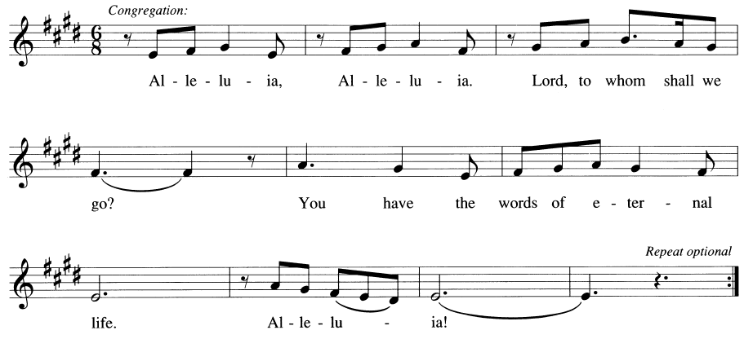

*Gospel – John 17:1-11
P: The holy gospel according to John the 17th chapter.
C: Glory to you, O Lord.

¹ After Jesus had spoken these words to his disciples, he looked up to heaven and said, “Father, the hour has come; glorify your Son so that the Son may glorify you, ² since you have given him authority over all people, to give eternal life to all whom you have given him. ³ And this is eternal life, that they may know you, the only true God, and Jesus Christ, whom you have sent. ⁴ I glorified you on earth by finishing the work that you gave me to do. ⁵ So now, Father, glorify me in your own presence with the glory that I had in your presence before the world existed.
⁶ “I have made your name known to those whom you gave me from the world. They were yours, and you gave them to me, and they have kept your word. ⁷ Now they know that everything you have given me is from you, ⁸ for the words that you gave to me I have given to them, and they have received them and know in truth that I came from you, and they have believed that you sent me. ⁹ I am asking on their behalf; I am not asking on behalf of the world but on behalf of those whom you gave me, because they are yours. ¹⁰ All mine are yours, and yours are mine, and I have been glorified in them. ¹¹ And now I am no longer in the world, but they are in the world, and I am coming to you. Holy Father, protect them in your name that you have given me, so that they may be one, as we are one.”

P: This is the Gospel of the Lord!
C: Praise to you, O Christ.

Children’s Sermon/Sermon

Hymn of the Day – “I, The Lord of Sea and Sky” – ELW 574
Nicene Creed
A: Let us profess our Christian faith with the words of the Nicene Creed:
We believe in one God, the Father, the Almighty, maker of heaven and earth, of all that is, seen and unseen.
We believe in one Lord, Jesus Christ, the only Son of God, eternally begotten of the Father, God from God, Light from Light, true God from true God, begotten, not made, of one Being with the Father; through him all things were made. For us and for our salvation he came down from heaven, was incarnate of the Holy Spirit and the virgin Mary and became truly human. For our sake he was crucified under Pontius Pilate; he suffered death and was buried. On the third day he rose again in accordance with the scriptures; he ascended into heaven and is seated at the right hand of the Father. He will come again in glory to judge the living and the dead, and his kingdom will have no end.
We believe in the Holy Spirit, the Lord, the giver of life, who proceeds from the Father and the Son, who with the Father and the Son is worshiped and glorified, who has spoken through the prophets. We believe in one holy catholic and apostolic church. We acknowledge one baptism for the forgiveness of sins. We look for the ☩ resurrection of the dead, and the life of the world to come. Amen.

Prayers of the People
Trusting in the power of Christ’s resurrection to heal and redeem our broken world, let us pray for the needs of all creation. A brief silence.
O God, your people sing praises throughout the church. By your Holy Spirit, inspire musicians, deacons, pastors, and bishops to proclaim the gospel of Jesus. Merciful God,
receive our prayer.
Your creative power fills the universe. Bring favorable weather, nurture plants and animals, protect us from natural disasters, and guide us to care for all you have made. Merciful God,
receive our prayer.
Your justice is exercised in society by those in authority. Instill in political leaders, business leaders, school administrators, and all who care for others a desire for peace and equity. Merciful God,
receive our prayer.
Your compassion and care come through the gifts of medicine and relationships. Soothe the anxious, protect widows and orphans, comfort those living with memory loss and their families, and heal the sick (especially). Merciful God,
receive our prayer.
Your love radiates from communities gathered in your name. Bless those experiencing significant transitions in life such as graduation, retirement, new employment, and accompany us in our prayers during these times. Merciful God,
receive our prayer.
O God, your promise of eternal life is certain and sure. Inspire us by the steadfast faith of those who have gone before us, so that we may be confident in the assurances you give. Merciful God,
receive our prayer.
God of resurrection power, use us and these prayers to proclaim the good news of new life to all the world, through Jesus Christ, our risen Savior. Amen.

*Sharing God’s Peace
A: The peace of the Lord be with you always.
C: And also with you.
A: Let us now offer peace to one another as you feel comfortable
Announcements

Offering
A: Let us now return to God, that which God has first given us – our tithes and our offerings.

Musical Offering

*Offering Canticle – “As the Grains of Wheat”
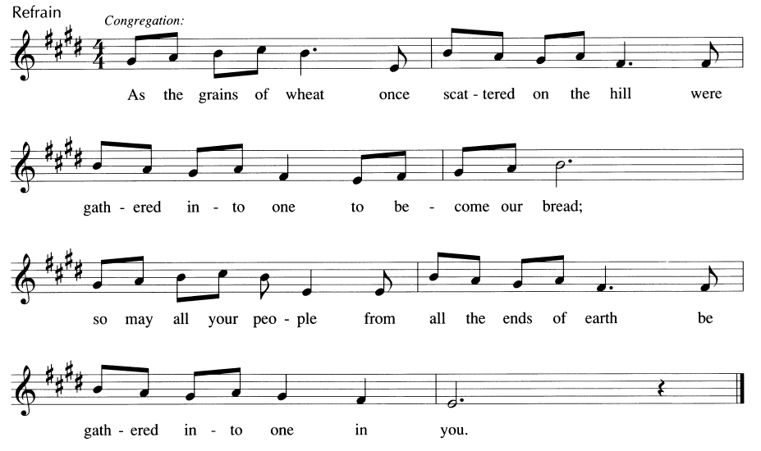
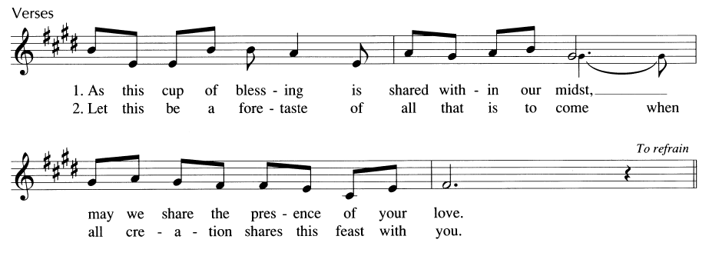

*Offering Prayer
A: Let us pray, Merciful God, accept the fruits of our labor, gathered to give you glory. You have set a table before us, a glimpse of that great day when we will hunger and thirst no more. Nourish us with the body and blood of Jesus, that goodness and mercy may follow us and bless the world you love.
C: Amen

*Great Thanksgiving
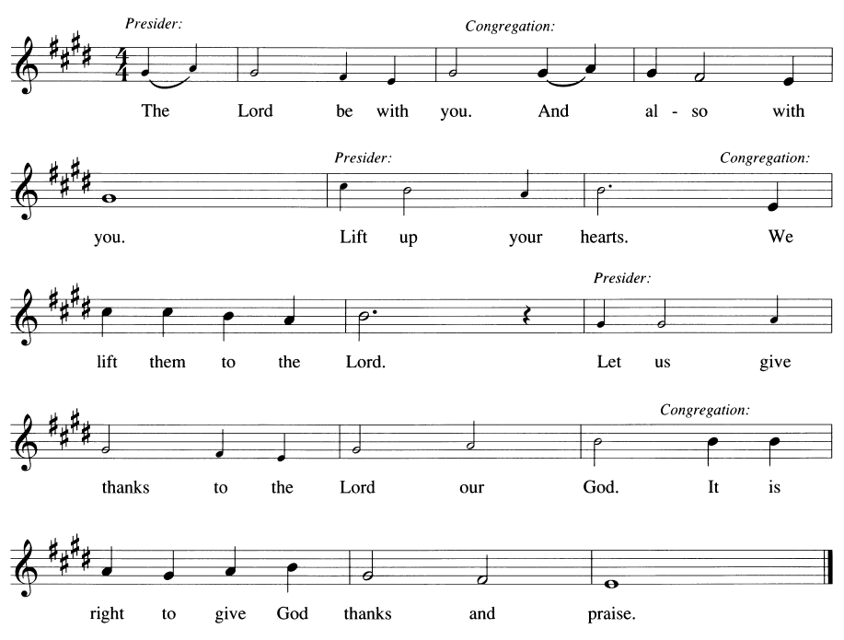

*Proper Preface
P: It is our duty and delight that we should everywhere and always offer thanks and praise to you, O God, through Jesus Christ
Who by his death on the cross and glorious resurrection broke the bonds of sin and death and gave life to all creation.
And so with the church on earth, all creation and the host of heaven, we praise your name and join their unending hymn!

*Sanctus
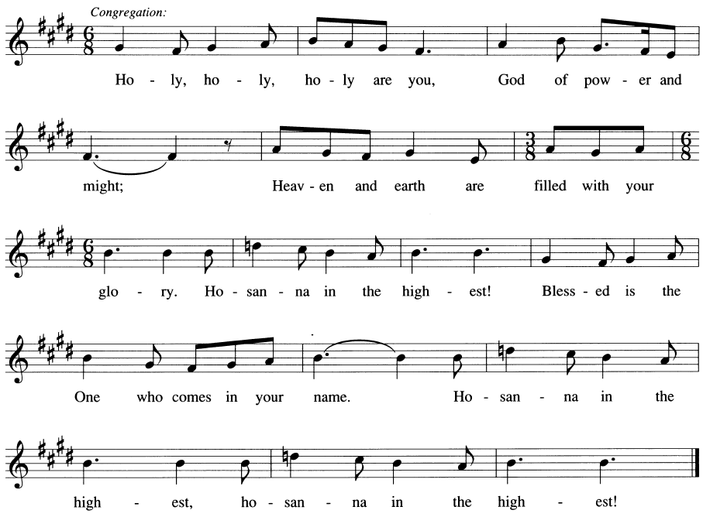
*Eucharistic Prayer
P: You are indeed holy, gracious, and merciful God; everything is filled with your glory. We give you thanks for your promise and presence which have sustained the faithful in this and every generation. Above all, we give you thanks for Jesus, born of Mary, who in word and deed announced your gentle rule of justice, reconciliation, and peace.

*Words of Institution
P: On the night of his betrayal, our Lord Jesus took bread and gave thanks; broke it and gave it to his disciples saying: “Take and eat; this is my body given for you. Do this for the remembrance of me.”

After supper, he took the cup, gave thanks, and gave it for all to drink saying: “This cup is the new covenant in my blood, shed for you and for all people for the forgiveness of sin. Do this for the remembrance of me.”

Remembering his command to love one another, his life and death, his resurrection, and his ascension, we pray for his coming again, even as we cry:

*Eucharistic Acclamation
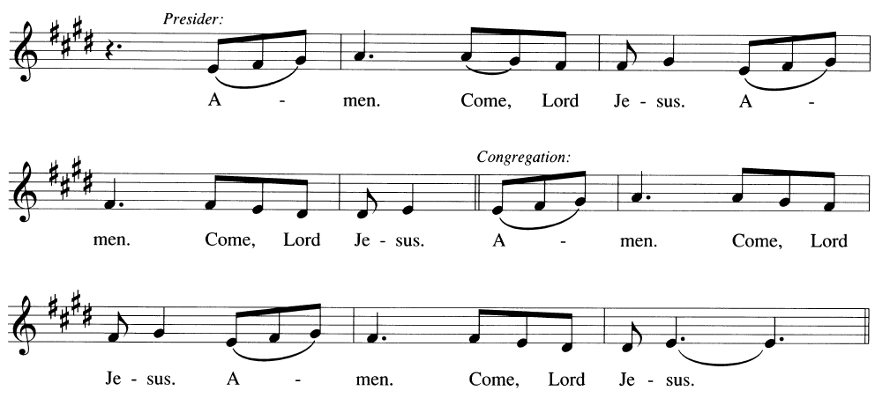

*Epiclesis
P: Send now, we pray, your Holy Spirit, that all of your promises may come to us and your whole creations.

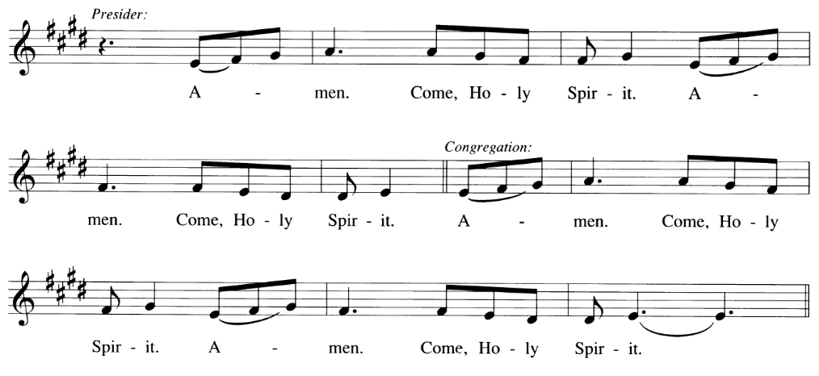
P: Gather our prayers with those of the apostles, prophets, martyrs, and all the faithful who have gone before us, and unite them with the unceasing prayer of the One who lives in us, and in whom we live, Jesus Christ.

“Through Christ, With Christ, In Christ”
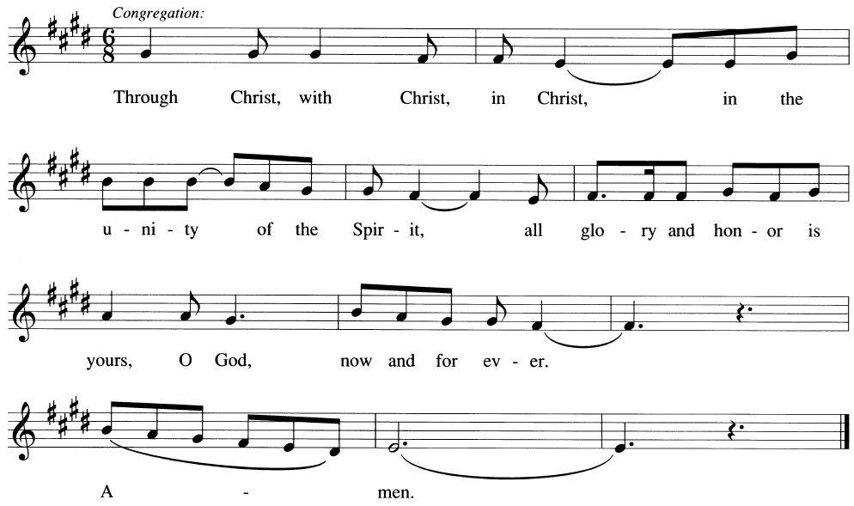

*Lord’s Prayer
P: Let us pray as our Lord has taught us
C: Our Father, who art in heaven, hallowed be thy name, thy kingdom come, thy will be done, on earth as it is in heaven. Give us this day our daily bread; and forgive us our trespasses, as we forgive those who trespass against us; and lead us not into temptation but deliver us from evil. For thine is the kingdom, and the power, and the glory, forever and ever. Amen.

*Invitation to Communion
P: Come to the table of new life. Receive the risen Lord. For all are welcome.

Agnus Dei
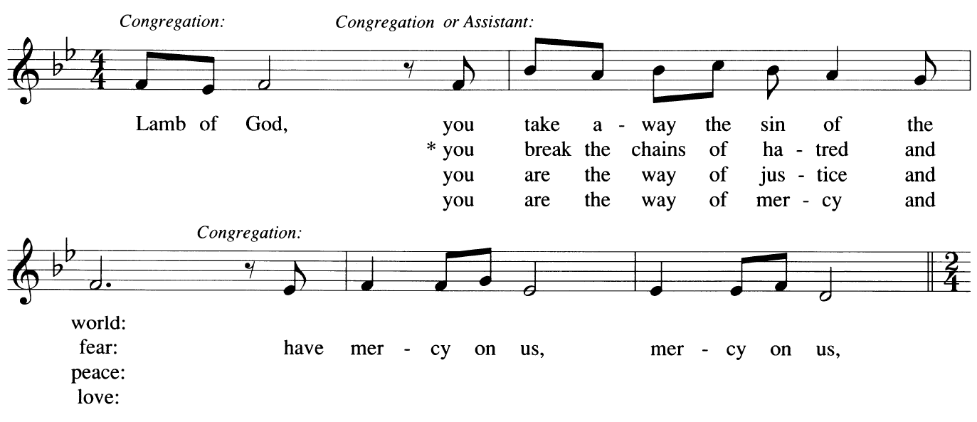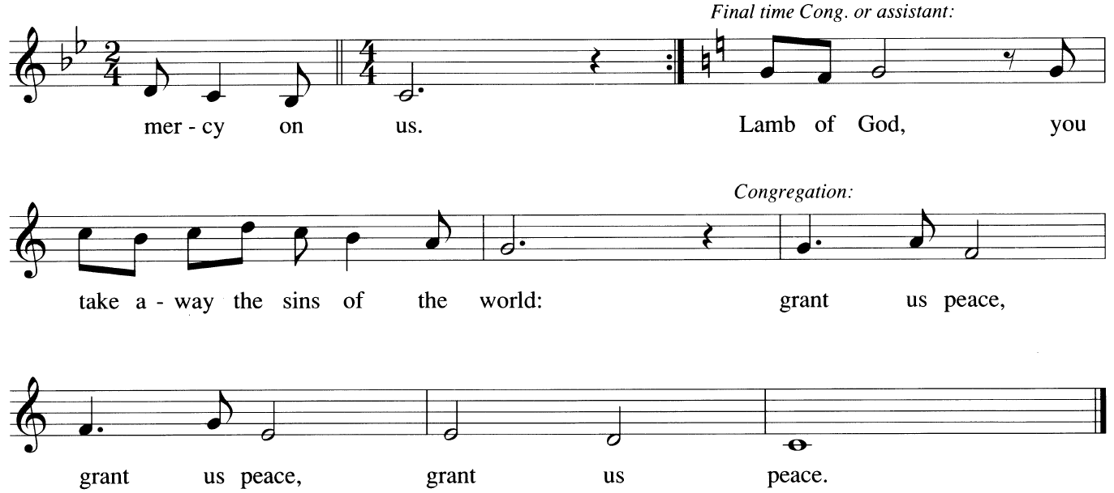

Communion Hymns
ELW 500 Now We Remain
ACS 939 Touch That Soothes and Heals (see insert)
ELW 843 Praise the One Who Breaks the Darkness

*Post Communion Blessing
P: The body and blood of our Lord Jesus Christ strengthen you, and forever ☩ keep you in his grace. C: Amen.

Farewell and Godspeed for a Retiring Pastor
Invitation
L: In the nineteenth chapter of First Kings, ¹⁵the Lord said to Elijah, ‘Go, return on your way to the wilderness of Damascus; when you arrive, you shall anoint Elisha son of Shaphat as prophet in your place. ¹⁹So Elijah set out from there, and found Elisha son of Shaphat, who was plowing. There were twelve yoke of oxen ahead of him, and he was with the twelfth. Elijah passed by him and threw his mantle over him.
L: Today we give thanks for the ministry of Pastor Scott, who has borne the mantle of pastoral office among us. As seasons change and ministries pass from one servant to another, we remember that Christ alone is the shepherd of the Church, the same yesterday, today, and forever.
Thanksgiving for Ministry
L: Pastor Scott, you have proclaimed the Gospel, administered the Sacraments, comforted the suffering, welcomed the stranger, and guided this congregation in faith. For your faithful service among us:
C: We give thanks to God.
L: For your care in times of sorrow and rejoicing:
C: We give thanks to God.
L: For your witness to the mercy and grace of Jesus Christ:
C: We give thanks to God.

Removal of the Stole
(The assisting minister approaches the pastor.)
L: In the Church, the stole is a sign of service undertaken in Christ’s name. Today, as Pastor Scott retires from active ministry among this congregation, this stole is laid down with thanksgiving for years of faithful labor.
(The stole is gently removed.)
L: Jesus said: “Take my yoke upon you, and learn from me; for I am gentle and humble in heart, and you will find rest for your souls.”
C: Thanks be to God for faithful servants who bear Christ’s yoke in love.
(The stole is placed upon the altar)

Laying on of Hands and Prayer
(Hands may be laid upon the pastor.)
L: Let us pray. Gracious God, through every season you call and send your servants. You strengthened Elijah for the journey, and called Elisha to continue the work. We thank you now for Pastor Scott, for the years of ministry shared with this congregation, for steadfast faith, patient love, and faithful witness.
As this chapter of ministry comes to its close, grant rest from labor, joy in new beginnings, and continued delight in your presence. Renew your servant with peace, surround him with love, and keep him always in the care of Christ Jesus our Lord.
C: Amen.

Charge to the Congregation
L: People of God, the mission of Christ continues. The Spirit still calls. The Gospel still speaks. The Church still sings. Will you continue in the apostles’ teaching and fellowship, in the breaking of bread and the prayers?
C: We will, and we ask God to help us.
L: Will you support one another and continue the ministry entrusted to this congregation?
C: We will, and we ask God to help us.
Farewell and Godspeed
Leader: Pastor Scott, go now with our gratitude, our affection, and our prayers. The Lord who called you into ministry will remain faithful in all the days ahead.
C: God go with you. Christ go before you. The Spirit go beside you. Go in peace and joy.

*Blessing:
P: The Lord bless you and keep you. The Lord make his face shine upon you and be gracious to you. The Lord look upon you with favor and ☩ give you peace.
C: Amen.

*Sending Hymn – “We Are Marching” – ELW 866
*Sending
P: God’s Work! C: Our Hands!

*Dismissal
A: Go in peace, Serve the Lord. Alleluia, Christ is Risen!
C: Christ is Risen indeed! Alleluia!

Postlude

