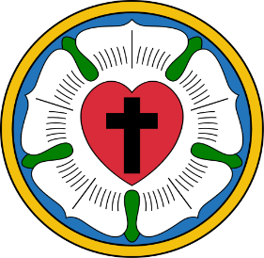White Roses Youth Group Schedule Fall-Winter 2024 Augustana Lutheran Church

207 N. Kelly Street Hobart IN

We meet Sundays 5-7pm

Sept 8 “Showing Partiality” James 2:1-17 Bonfire

Sept 15 “Who do you think you are?” Mark 8:27-38 Basketball

Sept 22 “God is our Helper” Psalm 54 Karaoke

Sept 29 “Be Salty!” Mark 9:38-50 Meal Gaga Ball

Oct 6 “Does God still speak?” Hebrews 1:1-4, 2:5-12 Cup Tournament

Oct 13 “Easier for a Camel” Mark 10:17-31 Movie Night

Oct 20 “You got served” Mark 10:35-45 Bonfire

Oct 27 “Sow in tears, reap in joy” Psalm 126 Spooky Party

Nov 3 “Super important stuff” Mark 12:28-34 Karaoke

Nov 10 “How to Praise 101” Psalm 146 Gaga Ball

Nov 17 “War what is it good for?” Mark 13:1-8 Cup Tournament

Nov 24 “What is truth anyway?” John 18:33-40 Movie Night

Dec 1 “Check yo self” Luke 21:25-36 ADVENT Service night

Dec 8 “Wilderness cry” Luke 3:1-6 ADVENT Christman Karaoke

Dec 15 “Youth Christmas Service and Party” ADVENT

Dec 22 OFF

Dec 29 OFF

White Roses Youth Group will return with new Winter/Spring 2025 Schedule

starting Jan 5,2025 Come as you are!

“Do not let ANYONE think less of you because you are young. Be an example to ALL believers..in what you SAY, in the way you LIVE, in your LOVE, your FAITH, and your PURITY.” 1 Timothy 4:12